**SOFT COMPUTING**

**ASSIGNMENT -5**

**Perumalla Dharan**

**AP21110010201**

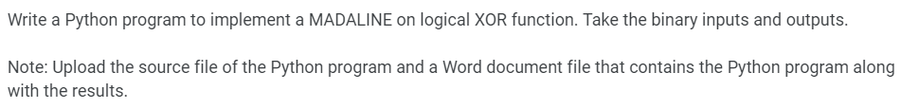

*import* numpy *as* np

class MADALINE:

def __init__(*self*, *learning_rate*=0.1, *iterations*=10000):

*self*.learning_rate = *learning_rate*

*self*.iterations = *iterations*

*self*.w = np.random.uniform(-0.5, 1, (2, 2))

*self*.b1 = np.random.uniform(-0.5, 1, 2)

*self*.v = np.random.uniform(-0.5, 1, (2, 1))

*self*.b2 = np.random.uniform(-0.5, 1, 1)

def fx(*self*, *x*):

*return* np.where(*x* >= 0, 1, 0)

def predict(*self*, *X*):

z_in = np.dot(*X*, *self*.w) + *self*.b1

z_out = *self*.fx(z_in)

y_in = np.dot(z_out, *self*.v) + *self*.b2

y_out = *self*.fx(y_in)

*return* y_out

def train(*self*, *X*, *y*):

*for* epoch *in* range(*self*.iterations):

*for* i *in* range(len(*X*)):

z_in = np.dot(*X*[i], *self*.w) + *self*.b1

z_out = *self*.fx(z_in)

y_in = np.dot(z_out, *self*.v) + *self*.b2

y_out = *self*.fx(y_in)

*if* y_out != *y*[i]:

*if* *y*[i] == -1:

*for* j *in* range(len(z_in)):

*if* z_in[j] > 0:

*self*.w[:, j] += (*self*.learning_rate * (*X*[i]) *(*y*[i]-z_in[j].item()))

*self*.b1[j] += (*self*.learning_rate * (*y*[i]-z_in[j].item()))

*elif* *y*[i] == 1:

closest_to_zero_index = np.argmin(np.abs(z_in))

*self*.w[:, closest_to_zero_index] += (*self*.learning_rate * *X*[i] *(*y*[i]-z_in[j].item()))

*self*.b1[closest_to_zero_index] += (*self*.learning_rate *(*y*[i]-z_in[closest_to_zero_index].item()))

*# Input Data for training (XOR logic)*

X = np.array([[0,0],

[0, 1],

[1, 0],

[1, 1]])

*# Input Data for testing (same as XOR)*

Z =np.array([[0,0],

[0, 1],

[1, 0],

[1, 1]])

y = np.array([[0], [1], [1], [0]])

madaline = MADALINE(*learning_rate*=0.1, *iterations*=10000)

madaline.train(X, y)

predictions = madaline.predict(Z)

*# Display results*

print("Testing Data:")

print(Z)

print("Predictions after training:")

print(predictions)

